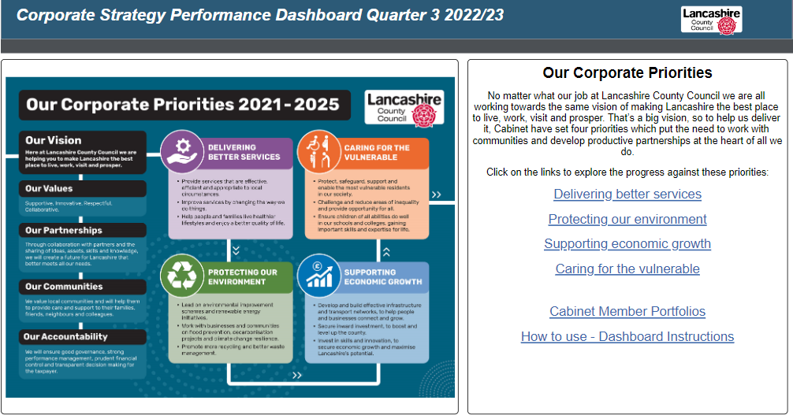

Link to Home Screen of Corporate Performance Dashboard: [Corporate Performance Dashboard](https://app.powerbi.com/view?r=eyJrIjoiYjJkNTI4OGUtYjkxMy00N2JmLWJlZTYtZDY4ZDM0ZDRiM2UwIiwidCI6IjlmNjgzZTI2LWQ4YjktNDYwOS05ZWM0LWUxYTM2ZTRiYjRkMiIsImMiOjh9&pageName=ReportSection)

